Cardiff and Vale Local Public Health Team Sexual Health Bulletin- Autumn 2021
A student guide to sexual health in Cardiff
This on line guide for new and current students has information on the sexual health support available in Cardiff and The Vale of Glamorgan. It contains information on organisations and services that will enable students to look after their sexual health.
The guide has links to support and services on Contraception, Sexually Transmitted Infection (STI) testing, pregnancy advice, accessing condoms, PrEP and more.
The link below can be easily shared. Click to see the full guide.
A Student Guide to Sexual Health in Cardiff – Fast Track Cardiff & Vale

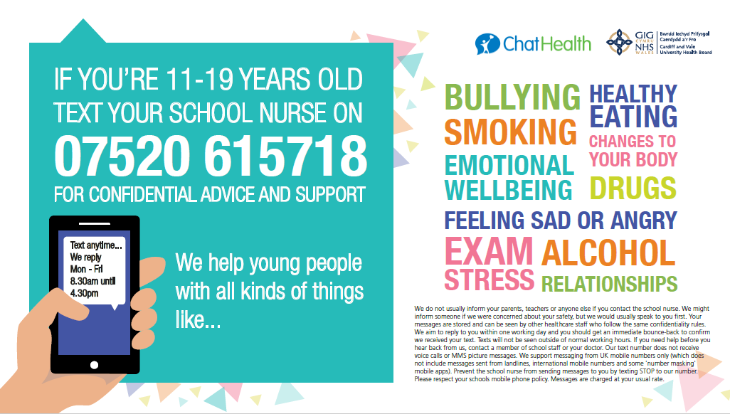

11-19 year olds can access free and confidential advice and support from a school nurse through the Chat Health Service. A school nurse can provide confidential support and advice on a range of topics including relationships and sexual health.

HealthPathways offers clinicians locally agreed information to make the right decisions together with patients, at the point of care. The pathways, designed primarily for general practice teams, are also available to specialists, allied health professionals and other health professionals. Visit the HealthPathways site by clicking here: https://cardiffandvale.communityhealthpathways.org
The login details: Username - HealthPathways Password- HealthPathways

There are currently 11 sexual health HealthPathways including:
Chlamydia https://cardiffandvale.communityhealthpathways.org/15532.htm

Genital Herpes https://cardiffandvale.communityhealthpathways.org/85339.htm

HIV https://cardiffandvale.communityhealthpathways.org/88220_1.htm

Pre-Exposure Prophylaxis (PrEP) for HIV https://cardiffandvale.communityhealthpathways.org/525496.htm

This training is for anyone who would like to deliver the C-Card Scheme. The scheme provides free, quick, easy and confidential access to condoms as well as advice and guidance on sexual health and relationships for young people aged 13 – 25 years. For further information or to book a place email: shot@ymcacardiff.wales
The Department of Sexual Health
Patients with symptoms or who think they may have an STI can make an appointment by calling: 02921 835208 Monday – Friday (excluding bank holidays) from 9am – 3pm.
A member of staff will take details and a clinician will call back. If urgent, an appointment may be booked to attend the department the same day. Alternatively, a face-to-face or video consultation may be booked on another day.
For full details visit https://cavuhb.nhs.wales/our-services/sexual-health
Test and Post – Home Testing for STI’s
People over the age of 16 who do not have symptoms can take a test for Chlamydia and Gonorrhoea and/or a test for HIV, Syphilis, Hepatitis B and Hepatitis C in their own home.
The kit has everything needed to complete the test. Once a sample has been collected, it is posted back in the Freepost envelope provided to the laboratory for testing. If results are positive, the local sexual health service will get in contact to arrange free and confidential treatment. For more information and to order a testing kit visit www.friskywales.org

Under 18’s Walk- in Clinic at Department of Sexual Health
From Tuesday 5th October there will be a dedicated walk-in clinic for those aged 18 and under providing contraception, pregnancy testing, STI testing and treatment and more.
The clinic will run every Tuesday from 2-5pm at Department of Sexual Health,
Cardiff Royal Infirmary, Glossop Road, Cardiff, CF24 0SZ.
For more details visit: https://cavuhb.nhs.wales/our-services/sexual-health

Pregnancy Advisory Service (including abortion treatment and care)
Patients can self-refer to the Pregnancy Advisory Service (PAS) Clinic
Tel: 02920 742638. Monday to Thursday 8.30am -12.30pm and 1.30pm-4.30pm. Friday 8.30am-12.30pm and 1.30pm-4.00pm. There is an answer-phone service outside these times.

